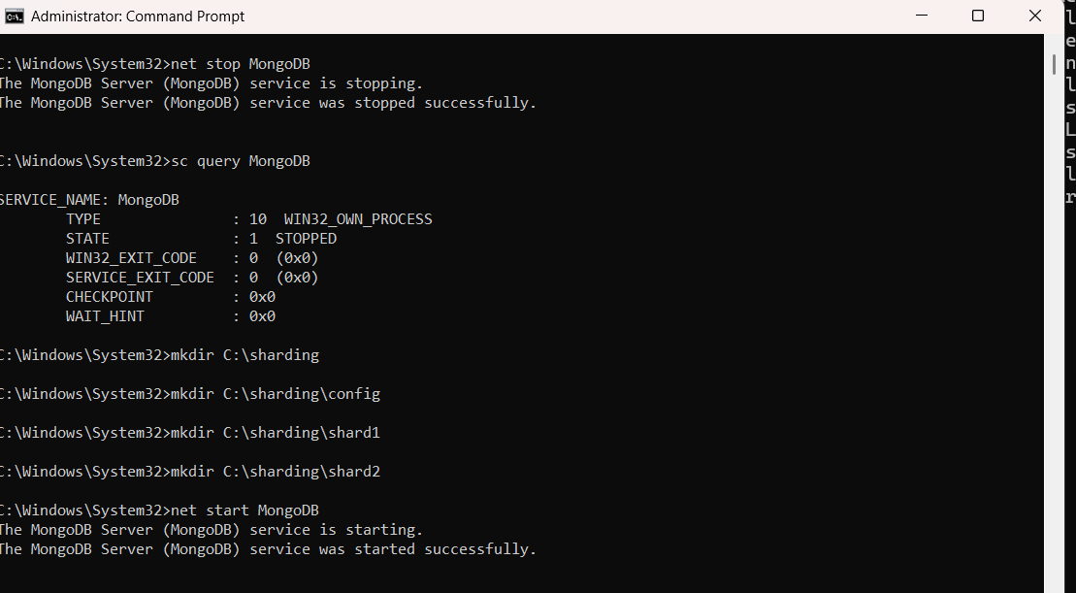

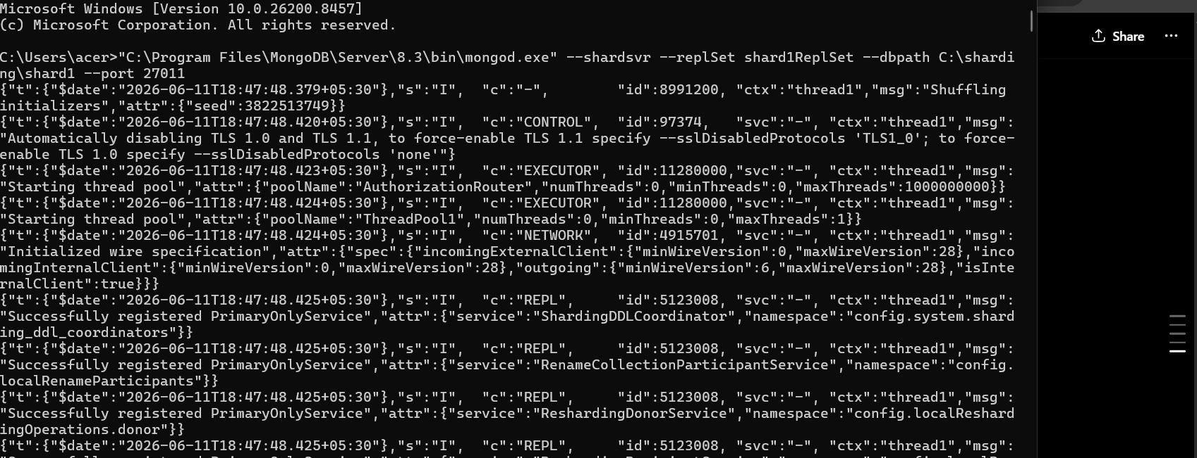

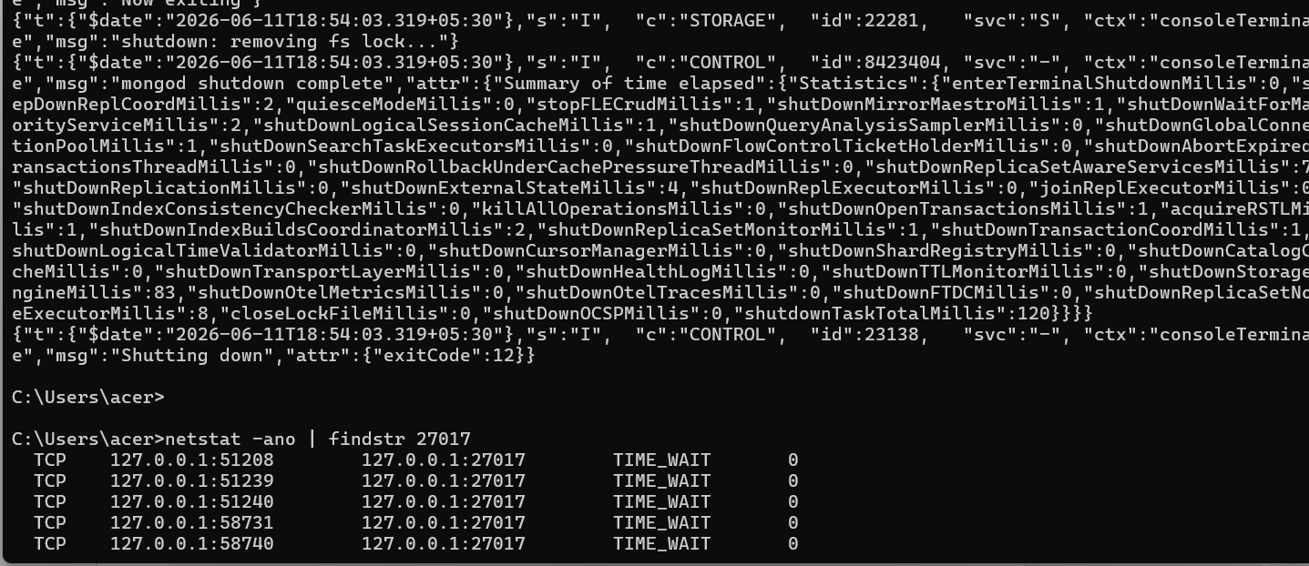

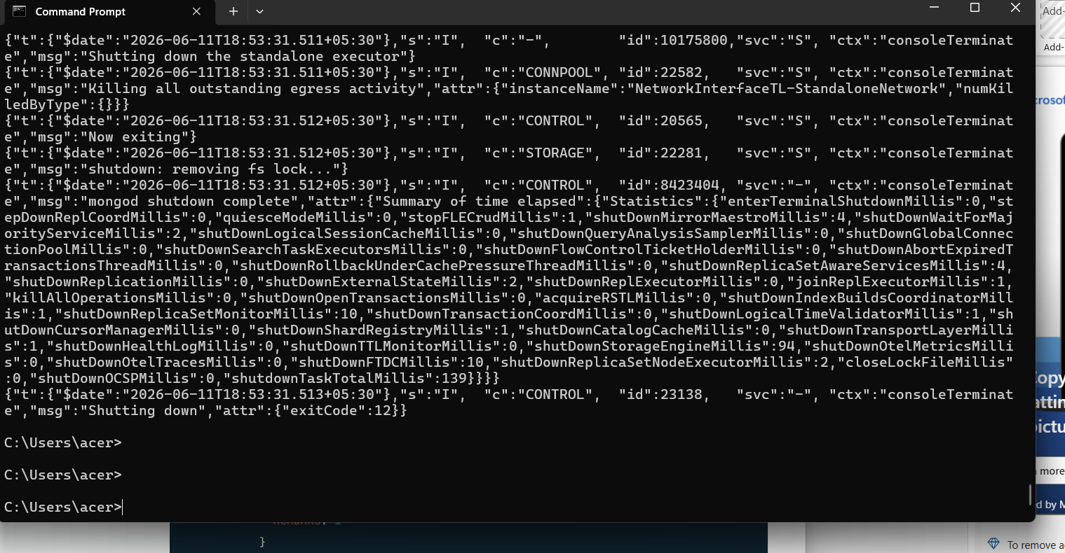

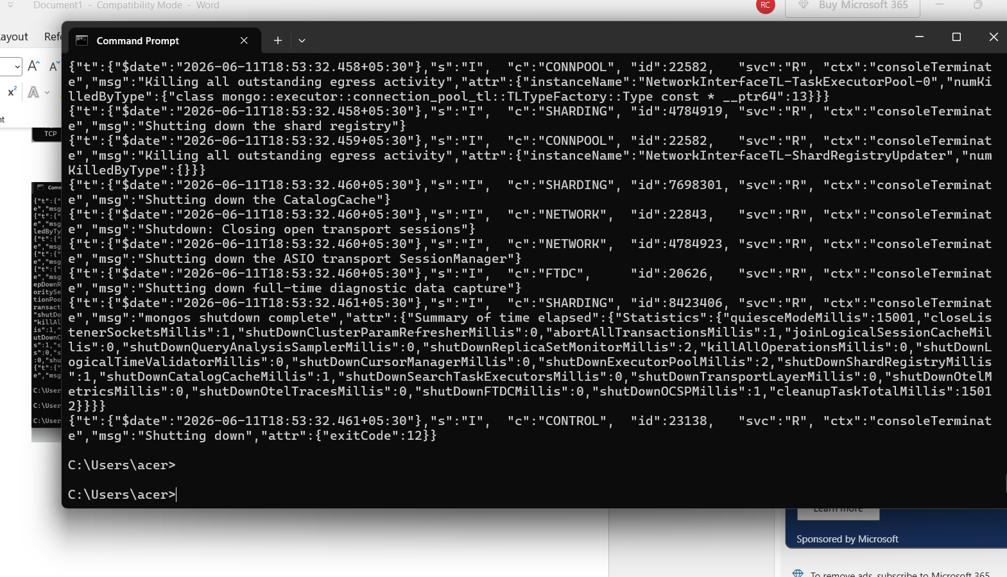

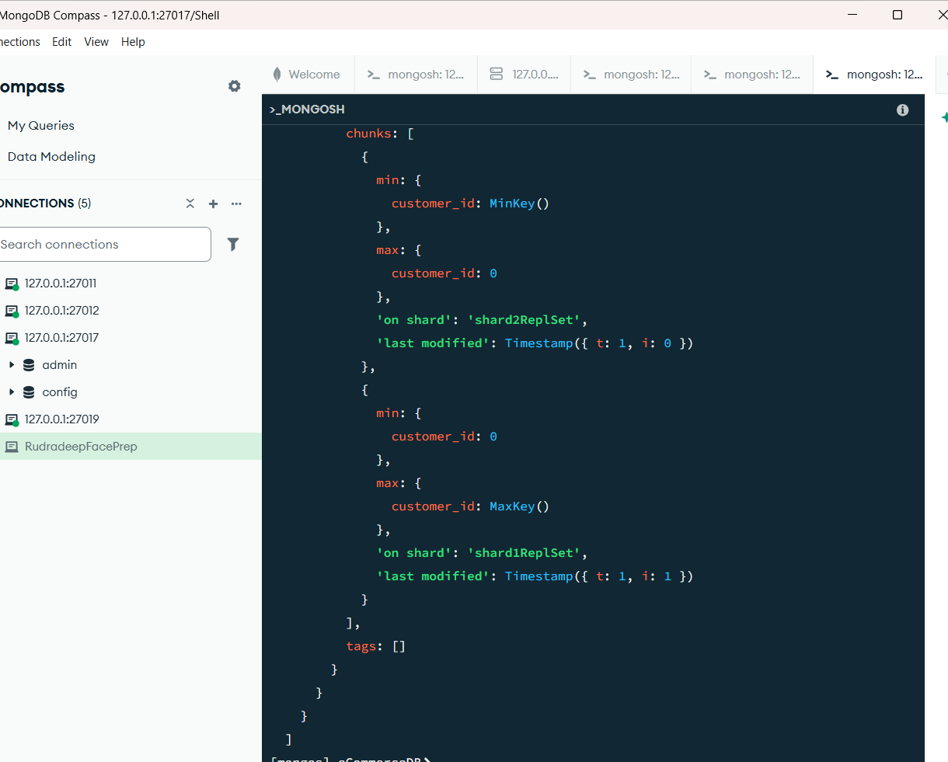

MAIN SHARDING:
sh.addShard("shard1ReplSet/localhost:27011")
sh.addShard("shard2ReplSet/localhost:27012")
{
shardAdded: 'shard2ReplSet',
ok: 1,
'$clusterTime': {
clusterTime: Timestamp({ t: 1781184130, i: 3 }),
signature: {
hash: Binary.createFromBase64('AAAAAAAAAAAAAAAAAAAAAAAAAAA=', 0),
keyId: Long('0')
}
},
operationTime: Timestamp({ t: 1781184130, i: 3 })
}
sh.enableSharding("eCommerceDB")
{
ok: 1,
'$clusterTime': {
clusterTime: Timestamp({ t: 1781184143, i: 21 }),
signature: {
hash: Binary.createFromBase64('AAAAAAAAAAAAAAAAAAAAAAAAAAA=', 0),
keyId: Long('0')
}
},
operationTime: Timestamp({ t: 1781184143, i: 21 })
}
sh.shardCollection(
"eCommerceDB.orders",
{ customer_id: "hashed" }
)
{
collectionsharded: 'eCommerceDB.orders',
ok: 1,
'$clusterTime': {
clusterTime: Timestamp({ t: 1781184152, i: 46 }),
signature: {
hash: Binary.createFromBase64('AAAAAAAAAAAAAAAAAAAAAAAAAAA=', 0),
keyId: Long('0')
}
},
operationTime: Timestamp({ t: 1781184152, i: 45 })
}
use eCommerceDB
for(let i=0;i<1000;i++){
db.orders.insertOne({
customer_id:"cust_"+i,
amount:Math.random()*100
})
}
switched to db eCommerceDB
sh.status()
shardingVersion
{
_id: ObjectId('6a2ab5562b73587981c913d8'),
clusterId: ObjectId('6a2ab5562b73587981c913d7')
}

shards
[
{
_id: 'shard1ReplSet',
host: 'shard1ReplSet/localhost:27011',
topologyTime: Timestamp({ t: 1781184128, i: 32 }),
replSetConfigVersion: -1
},
{
_id: 'shard2ReplSet',
host: 'shard2ReplSet/localhost:27012',
topologyTime: Timestamp({ t: 1781184129, i: 36 }),
replSetConfigVersion: -1
}
]

active mongoses
[
{
'8.3.2': 1
}
]

autosplit
{
'Currently enabled': 'yes'
}

balancer
{
'Currently enabled': 'yes',
'Currently running': 'no',
'Failed balancer rounds in last 5 attempts': 0,
'Migration Results for the last 24 hours': 'No recent migrations'
}

shardedDataDistribution
[
{
ns: 'eCommerceDB.orders',
shards: [
{
shardName: 'shard1ReplSet',
numOrphanedDocs: 0,
numOwnedDocuments: 0,
ownedSizeBytes: 0,
orphanedSizeBytes: 0
},
{
shardName: 'shard2ReplSet',
numOrphanedDocs: 0,
numOwnedDocuments: 0,
ownedSizeBytes: 0,
orphanedSizeBytes: 0
}
]
}
]

databases
},
{
database: {
_id: 'eCommerceDB',
primary: 'shard1ReplSet',
version: {
uuid: UUID('76f00581-1d69-4f6c-8d74-f19a26a39a26'),
timestamp: Timestamp({ t: 1781184143, i: 9 }),
lastMod: 1
}
},
collections: {
'eCommerceDB.orders': {
shardKey: {
customer_id: 'hashed'
},
unique: false,
balancing: true,
allowMigrations: true,
chunkMetadata: [
{
shard: 'shard1ReplSet',
nChunks: 1
},
{
shard: 'shard2ReplSet',
nChunks: 1
}
],
chunks: [
{
min: {
customer_id: MinKey()
},
max: {
customer_id: 0
},
'on shard': 'shard2ReplSet',
'last modified': Timestamp({ t: 1, i: 0 })
},
{
min: {
customer_id: 0
},
max: {
customer_id: MaxKey()
},
'on shard': 'shard1ReplSet',
'last modified': Timestamp({ t: 1, i: 1 })
}
],
tags: []
}
}
}
]
-------------------------------------------------------------------------------------------------------------------------------------
rs.initiate({
_id: "configReplSet",
configsvr: true,
members: [
{ _id: 0, host: "localhost:27019" }
]
})
{
ok: 1,
'$clusterTime': {
clusterTime: Timestamp({ t: 1781183829, i: 1 }),
signature: {
hash: Binary.createFromBase64('AAAAAAAAAAAAAAAAAAAAAAAAAAA=', 0),
keyId: Long('0')
}
},
operationTime: Timestamp({ t: 1781183829, i: 1 })
}

rs.initiate({
_id: "shard1ReplSet",
members: [
{ _id: 0, host: "localhost:27011" }
]
})
{
ok: 1,
'$clusterTime': {
clusterTime: Timestamp({ t: 1781183913, i: 1 }),
signature: {
hash: Binary.createFromBase64('AAAAAAAAAAAAAAAAAAAAAAAAAAA=', 0),
keyId: Long('0')
}
},
operationTime: Timestamp({ t: 1781183913, i: 1 })
}
rs.initiate({
_id: "shard2ReplSet",
members: [
{ _id: 0, host: "localhost:27012" }
]
})
{
ok: 1,
'$clusterTime': {
clusterTime: Timestamp({ t: 1781183962, i: 1 }),
signature: {
hash: Binary.createFromBase64('AAAAAAAAAAAAAAAAAAAAAAAAAAA=', 0),
keyId: Long('0')
}
},
operationTime: Timestamp({ t: 1781183962, i: 1 })
}

